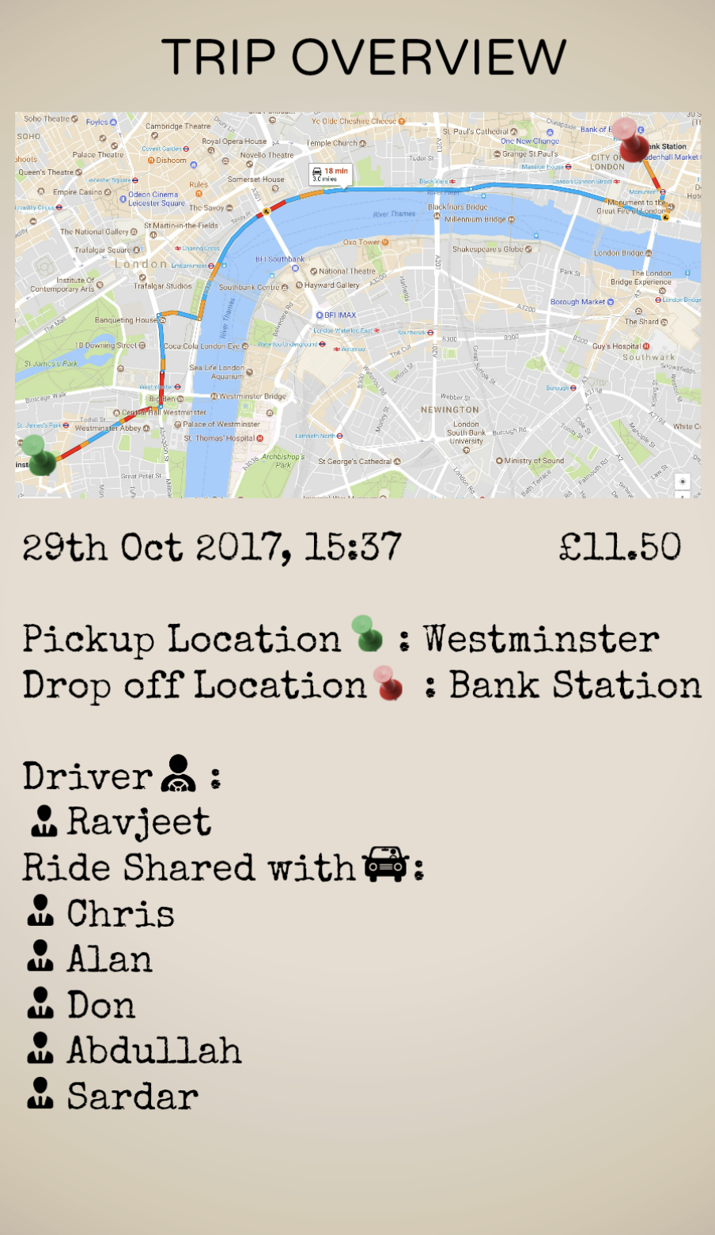**TRIP OVERVIEW SCREEN**